Year 5 and 6 Homework – Friday 9th October
Homework will be handed out on Fridays and collected in on Wednesdays. Homework will be uploaded to the school website but paper copies will be handed out on request.
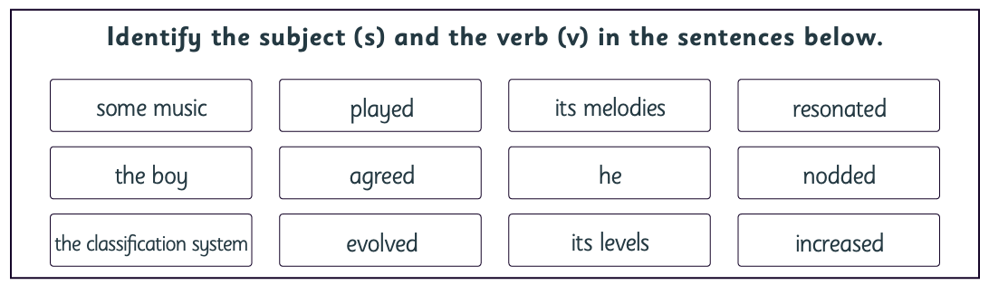
English: complete both tasks

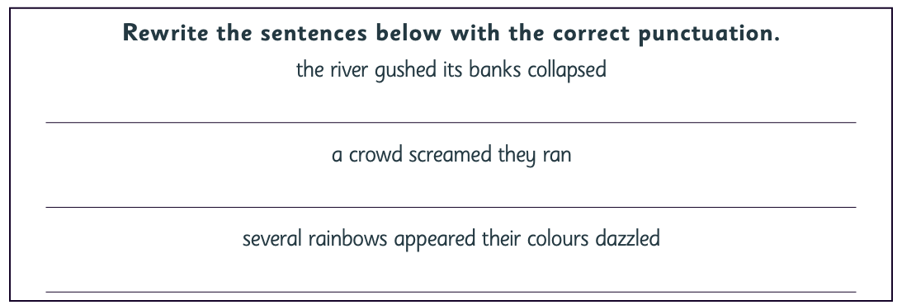

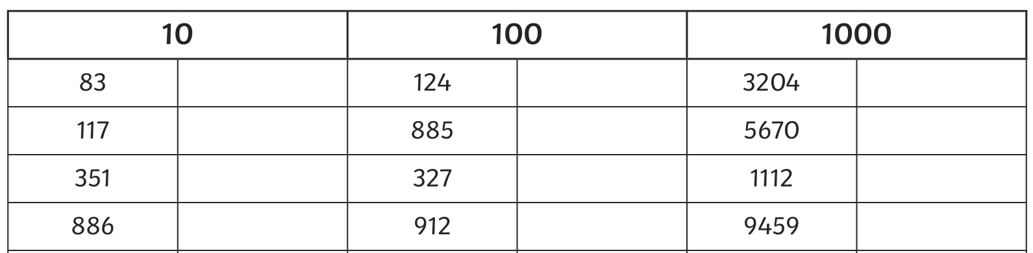
Maths: rounding practise

